Open ECAR

Open Electric Vehicle dashboard project
Open source (GPLv2)
© Abylay Ospan, 2018
https://jokersys.com/

Requirements: OS Linux (Ubuntu)
Hardware: Raspberry Pi3, Nvidia Jetson TX2
Data: CAN-bus
Reference car: Mercedes Smart fortwo electric 2014
Framework: Qt
Hosting: https://github.com/ and https://jokersys.com/
Binary/repository name: openecar_dashboard
Command line arguments: -d /dev/can0

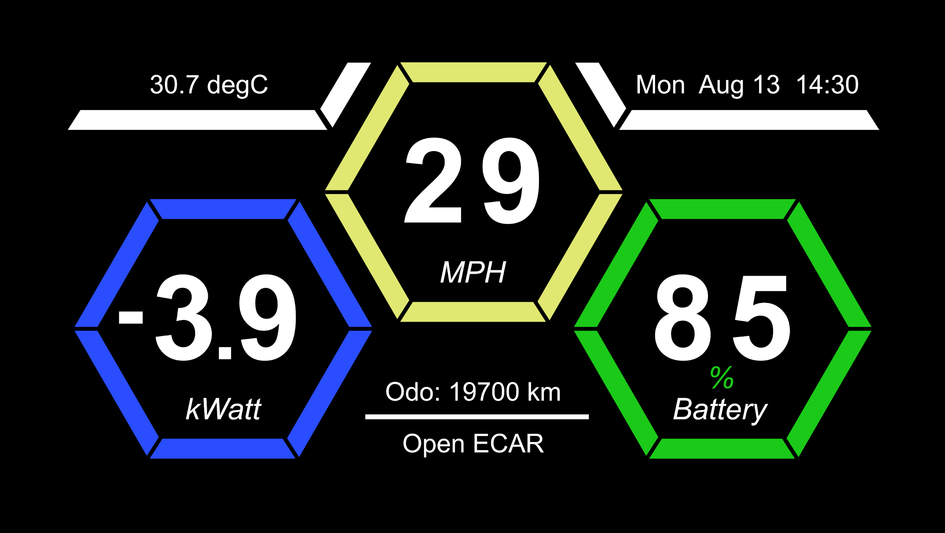
Pic. 2 Basic dashboard mockup

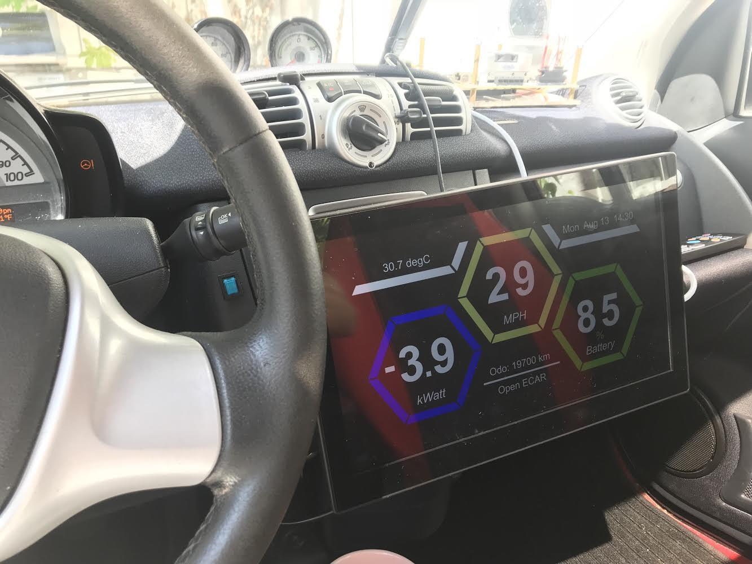
Pic. 3 Prototype photo (electric smart fortwo)

Vector (ai file): https://drive.google.com/open?id=1YOQOuRkGTHs32ChMDKk3D-iLm7ixIxvF
Used fonts: Arial bold (digits), italic

Full screen and “minimize” mode. Can be placed on top of all other windows. Movable (by mouse or touch screen)
Refresh values instantly (as the arrive on CAN bus). Data/time as arrived from CAN bus.

Reading data from CAN bus

http://canable.io/ USB dongle used. Access to CAN bus obtained through OBD port (pins 6 and 14). Linux can0 device created. https://github.com/linux-can/can-utils can be used to access CAN bus from C/C++ code.

CAN bus dump can be created with command:

tshark -i 2 -w smart-fortwo-electric.pcap

Wireshark GUI can be used to examine this file.

For example, battery charge level (SOC) can be obtained from CAN message ID 0x2D5.
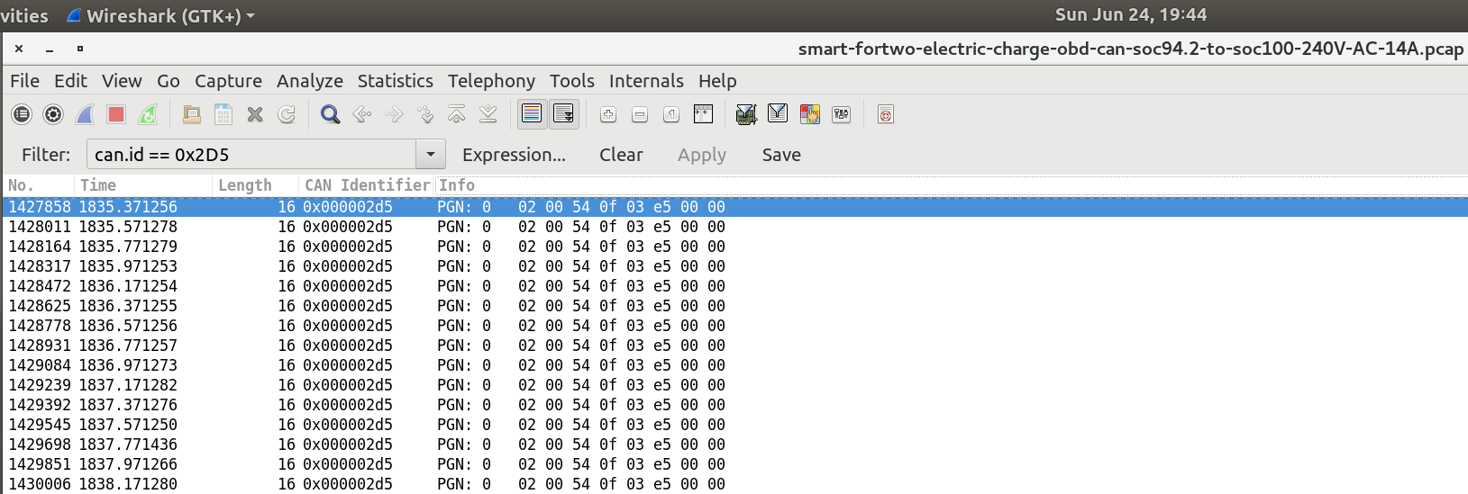
using this values we can get SOC state: ((0x03 & 0x03)*256 + 0xe5)/10 = 99.7%

BMS, cooling, charging, etc info can be decoded using information from following C source file (from ED BMSdiag project): canDiag.cpp here:

https://github.com/MyLab-odyssey/ED_BMSdiag/blob/master/ED_BMSdiag/canDiag.cpp

Debug screen (under discussion !)
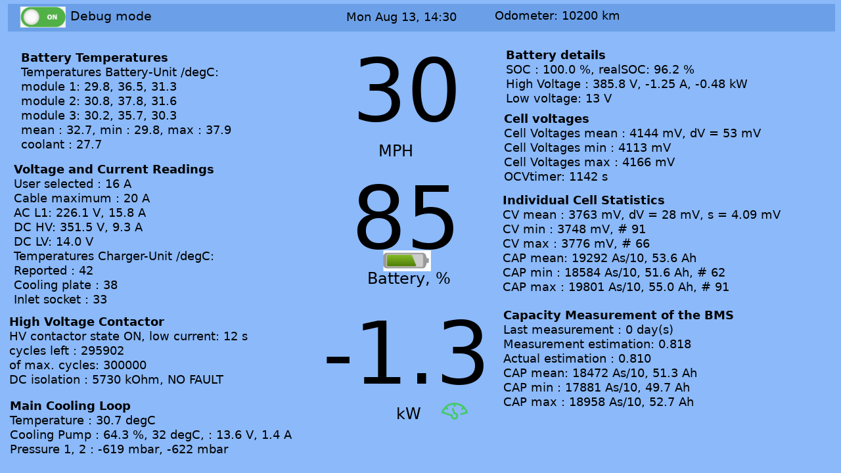
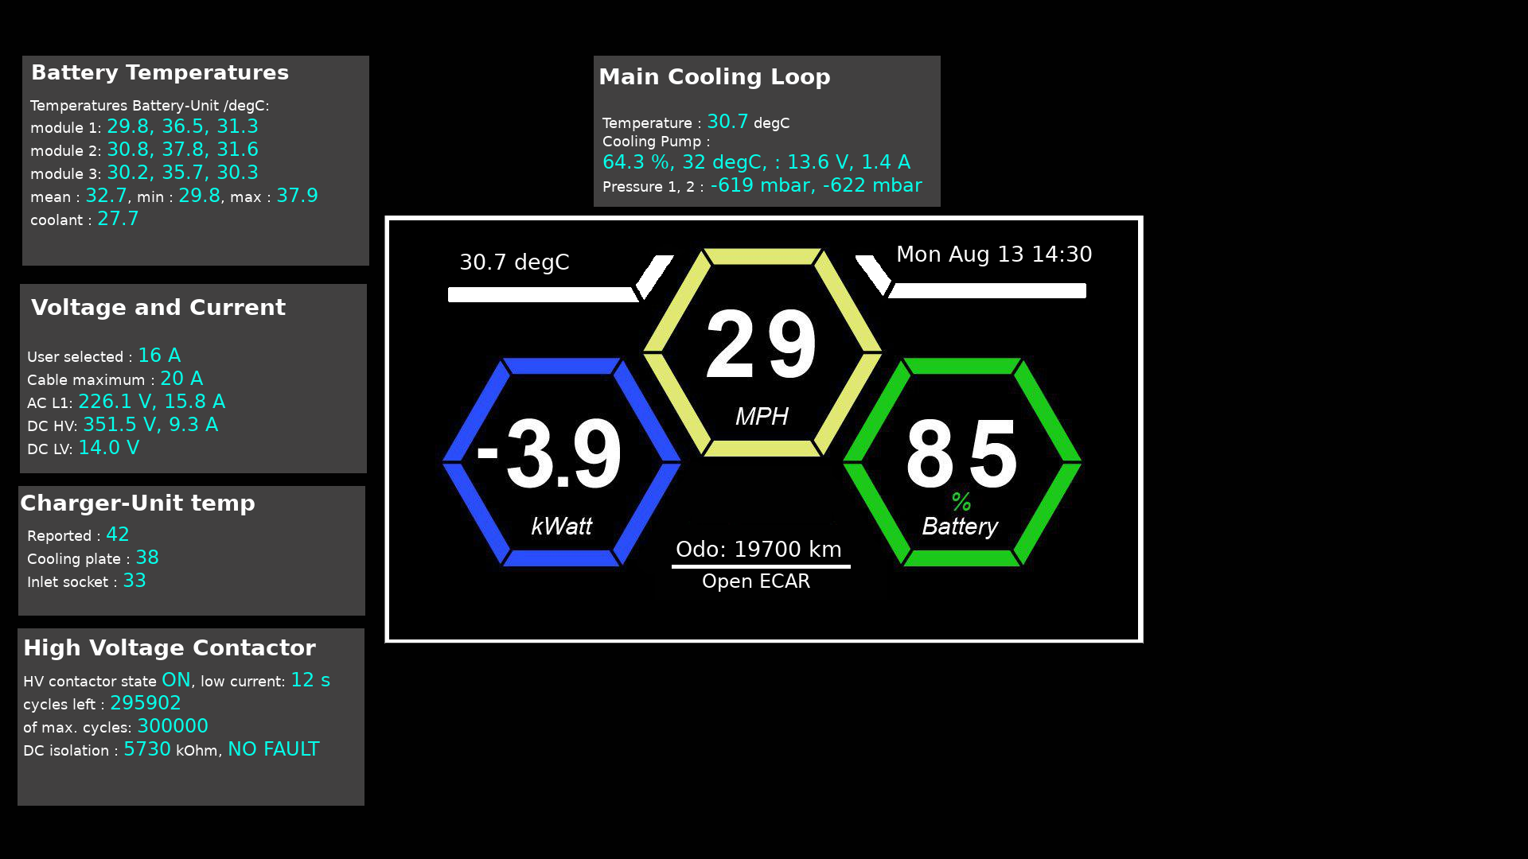
Pic. 3 Debug dashboard draft

Fields description:

https://github.com/MyLab-odyssey/ED_BMSdiag/wiki/Data-Overview

Some more info:

https://github.com/aospan/smart_fortwo_electric_charge_canbus/blob/master/README.md

Working prototype photos
